Abtract

The amount of traffic is ever-increasing these days in urban cities across the world. Handy information regarding traffic rules, safety measures, and blockages in important areas of a city on any given day can help people. This can impact day-to-day lives of individuals as well as emergency facilities.

Proposed Solution

The solution to the problem is to create an informational Web portal to provide informtion about traffic rules, safety measures, and blockages.

Individuals as well as persons from traffic control department can use this Website,

**DEFINITION OF THE PROBLEM**

After reading the project specifications, the developer states the scope of the project very briefly. This is referred to as the problem definition.

Question:

After consulting several IT companies and considering the budget constraints, the management of Urban Traffic Portal (UTP) has decided to launch the Web application as a Single Page Responsive Webapplication. Hence, the project will use:

AngularJS, and Bootstrap 4 libraries from getbootstrap.com, jQuery plugins, and Visual Studio Code editors. Also, the site will be tested on popular browsers and mobile emulator software.

**REQUIREMENT ANALYSIS**

**List of inputs to the system:**

**From the the traffic control department:**

Traffic Safety Measures and Traffic Rule Document (contain plain text, audio, video).

Traffic Information (road map, vehicle, history about the Traffic Blockage).

List of items susch as caps, placards, banners, flags that they can buy from website.

**From user (vehicle owner, Pedestrian):**

Name of the user

User type: vehiecle owner or Pedestrian

Report information about traffic blockages: location, time, status.

**From Traffice Police:**

Police provide detail information about the traffice status and the work they must do.

Explan how they can solve complex problem.

**List of outputs expected from the system**

**From the the traffic control department:**

Traffic Safety Measures and Traffic Rule Document (contain plain text, audio, video): display on the web as an organizer. Flexible way to watch video a listen the audio.

Traffic Information (road map, vehicle, history about the Traffic Blockage): setup the work flow of the traffic control tool.

List of items susch as caps, placards, banners, flags that they can buy from website: display on the website as an imge gallery.

**From user (vehicle owner, Pedestrian):**

First name display at the top the corner a duration all the time page loaded.

User type be use to choose the direction

Report information about traffic blockages: location, time, status. Will be update to Control Tool and visual present on the map.

**From Traffice Police:**

Police provide detail information about the traffice status and the work they must do.???

Explan how they can solve complex problem?

**Overview of processes involved in the system**

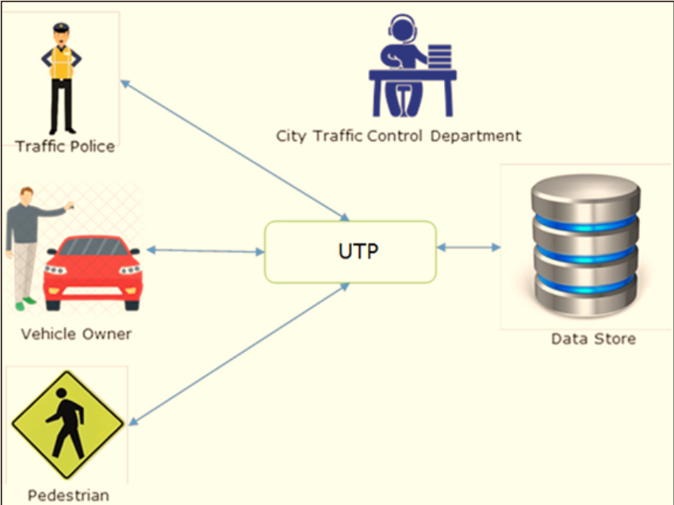

2.

3. Get the information from the json/text file to the page.

**Hardware and software required for implementing the project**

**Hardware**

Intel Core i3 Processor or higher

2 GB RAM or higher

Color SVGA

80 GB Hard Disk space

CD-ROM or DVD-ROM drive

**Software Requirements:**

Base: HTML5, CSS3, JavaScript, Geolocation API, Web Storage

Javascrip Framework: Angularjs 1.7.8, Jquery 3.3.1

CSS Framework: Boostrap 4.3.1

Font Awesome 5.8.1

Code editor: Visual Studio Code

**Scope of the work:**

**Function**

Depending on the decision taken by the management regarding the Urban Traffic portal, following are the requirements based on which the Single Page Application (SPA) needs to be developed:

Depending on the decision taken by the management regarding the Urban Traffic portal, following  
are the requirements based on which the Single Page Application (SPA) needs to be developed:

i. Welcome Message: The home page should accept first name from the user and display a personalized welcome message. At the top corner, the user's first name should be displayed for the entire duration that the portal is loaded.

ii. Traffic Safety Measures: Menu sub-options should include Audio Message and Video Message under Traffic Safety Measures main menu option. Based on the user's choice, traffic safety measures in the form of audio and video should be displayed to users in the center of the page. The audio and video files should be of appropriate browser-supported formats and should be short in duration.

iii. Traffic Rules: This menu option upon clicking should display traffic rules in the form of an image gallery, where each image will represent a rule.

iv. View Traffic Blockage Information: This menu option upon clicking should display traffic blockage information for the day provided by city traffic department. Traffic blockage text will include location, date, time, and description. Information will be retrieved from a pre-populated JSON file and displayed. (Hint: Use AngularJS directives, filters, services, controllers, and other features to implement this).

v. Reports: Upon clicking this menu option, users should be able to view reports of traffic blockages based on sorted order of date or location. (Hint: Retrieve the data from pre-populated JSON file using $http.get. Use AngularJS directives such as ng-repeat, filters such as OrderBy, services, controllers, and other features to implement this).

vi. Buy Traffic Safety Merchandise: Upon clicking this menu option, a variety of items such as caps, placards, banners, flags, and so on should be displayed in a tabular grid with respective image and price in currency such as dollars. (Hint: For displaying formatted currency, you can use the filters feature of AngularJS). The price details can be hard-coded in the form of text arrays. You need not implement the actual purchase functionality, as it will be beyond the scope of the site.

Over and above this, the portal should implement the following functionalities:

Display a continuous scrolling ticker at the bottom of the page with current date, time, and location (hint: Use geolocation features of HTML5).

Display a visitor count at the top right corner of the page beside a logo image.

The menu options should change color on hover and also after clicking.

Fade in and fade out options can be used for the menus.

**Design phase**

**Designing the GUI Standards**

**Assigning and Monitoring Tasks**

**Architecture of Website**

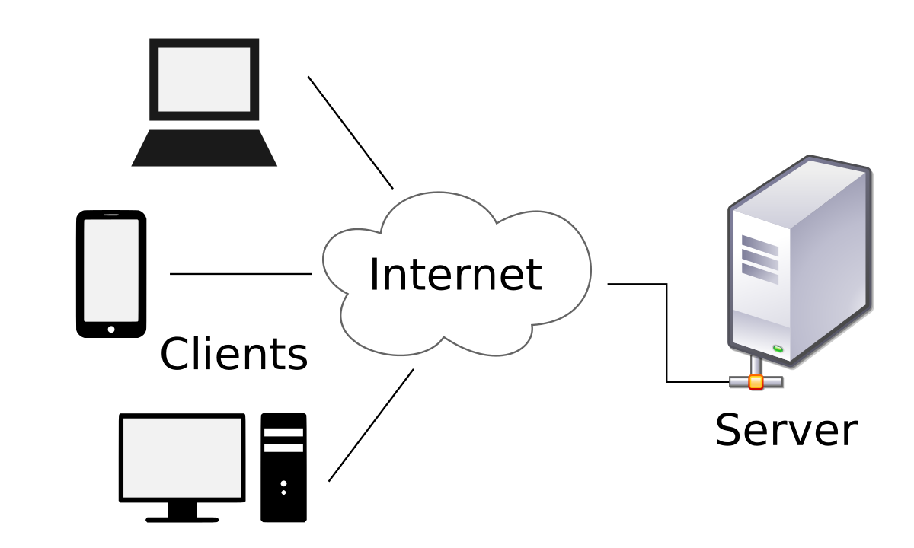

**Site Map**

**Evaluation/Testing**

**Project Tracking and Monitoring Activities**

**Documentation Section**

**Source Code**

**User Guide**